**CCD LAB EXPERIMENT: 3**

# AIM: To find out the output waveforms for the AM modulator and demodulator circuit design using IC 1496.

# A.] AM MODULATOR:

# CIRCUIT:

# Screenshot (868).png

# OUTPUT WAVEFORM ON THE OSCILLOSCOPE:

# WhatsApp Image 2020-11-02 at 16.21.13.jpeg

# 

# WhatsApp Image 2020-11-02 at 16.21.14.jpeg

# AM DEMODULATOR:

# CIRCUIT:

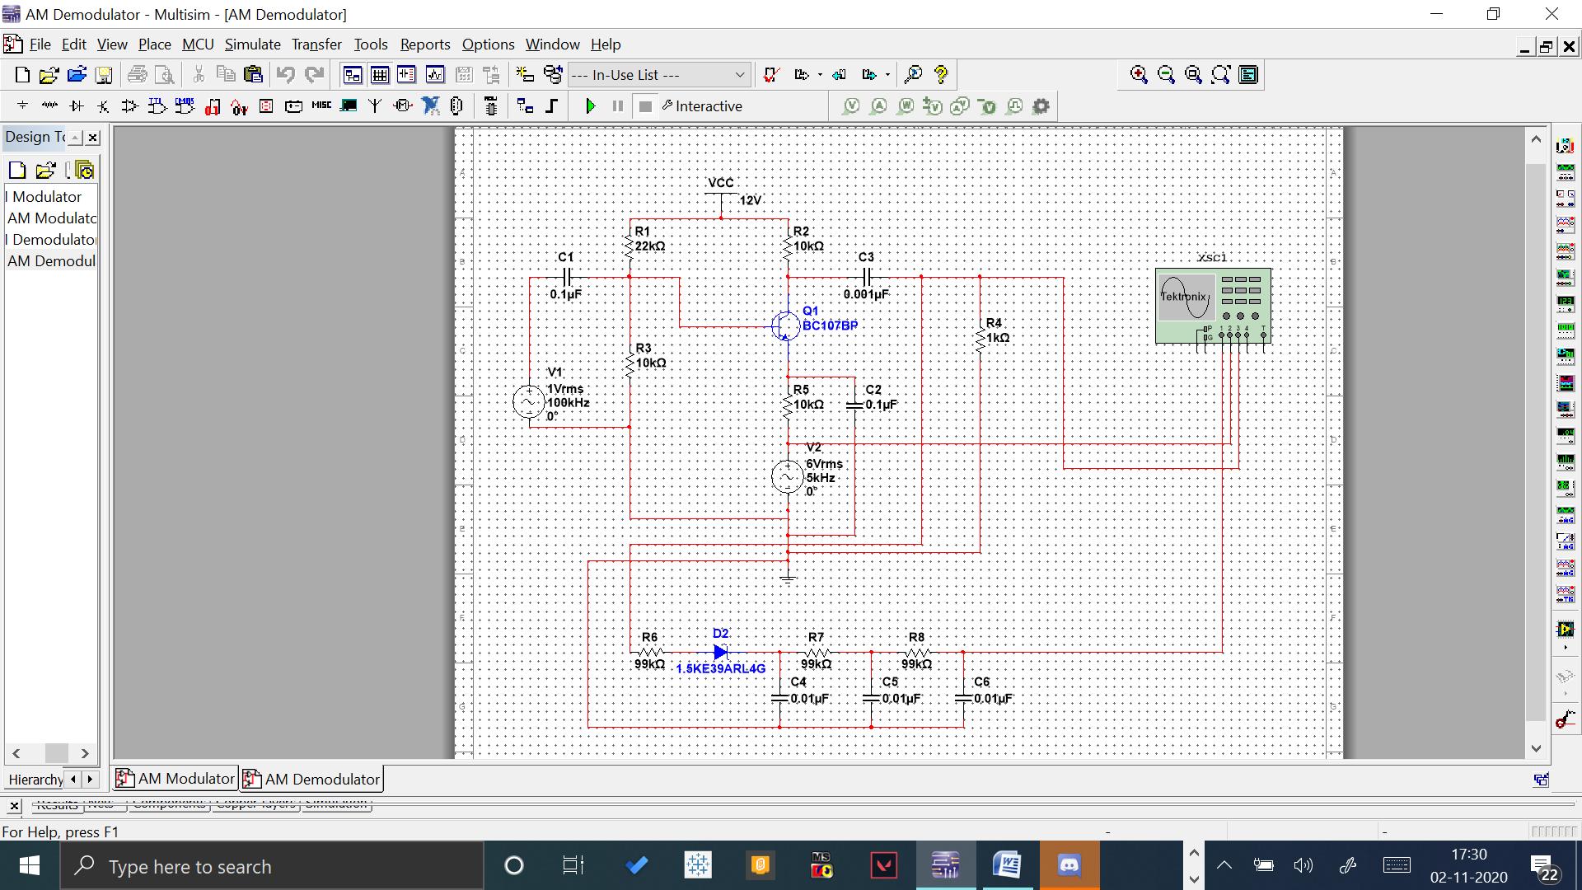

# OUTPUT WAVEFORM ON THE OSCILLOSCOPE:

# WhatsApp Image 2020-11-02 at 17.27.56.jpeg

**Conclusion:**  Observed the output waveforms for AM modulator and Demodulator circuit design using IC 1496 by simulating it in NI Multisim.